Reference:<https://codelabs.developers.google.com/codelabs/automl-vision-edge-in-mlkit#1>

**A.Execute automl vision and timeseries forcasting models:**

**B. end2end deployment of a vision model using automl to mobile device**

1. Set up and Downloading Training code in firebase console

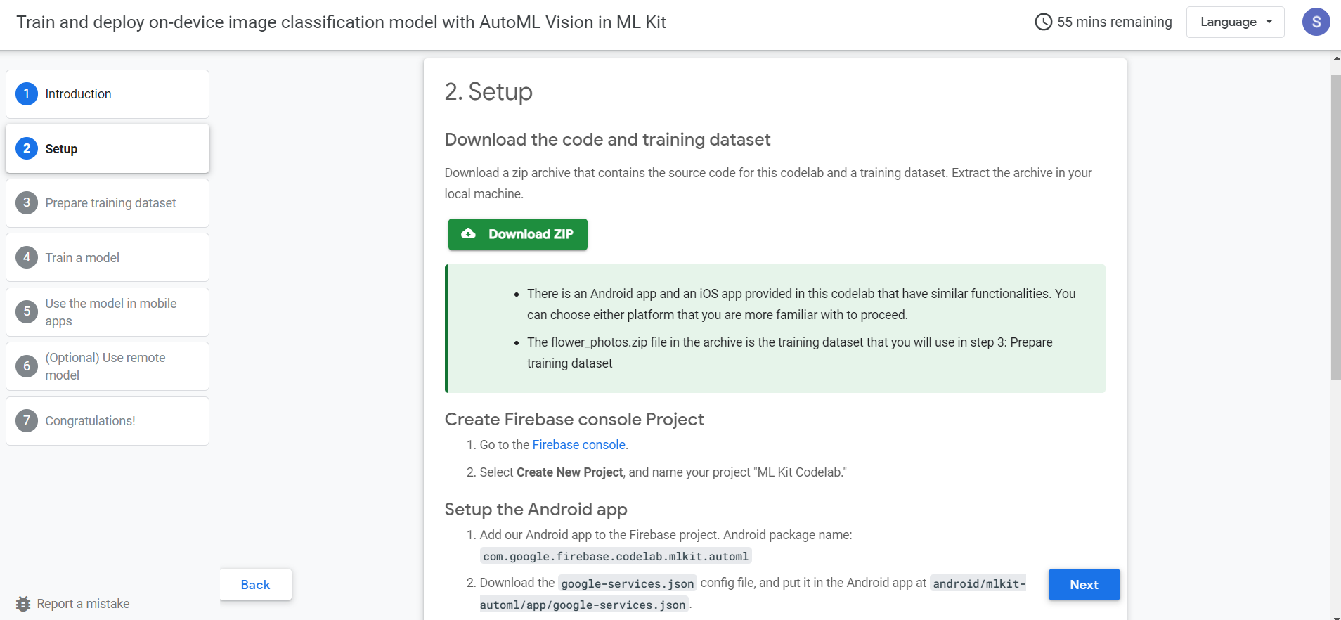

1. Creating project

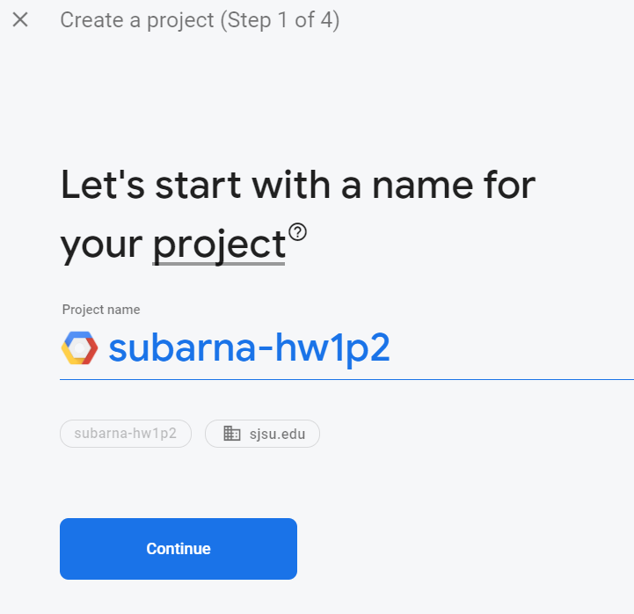

1. Next step

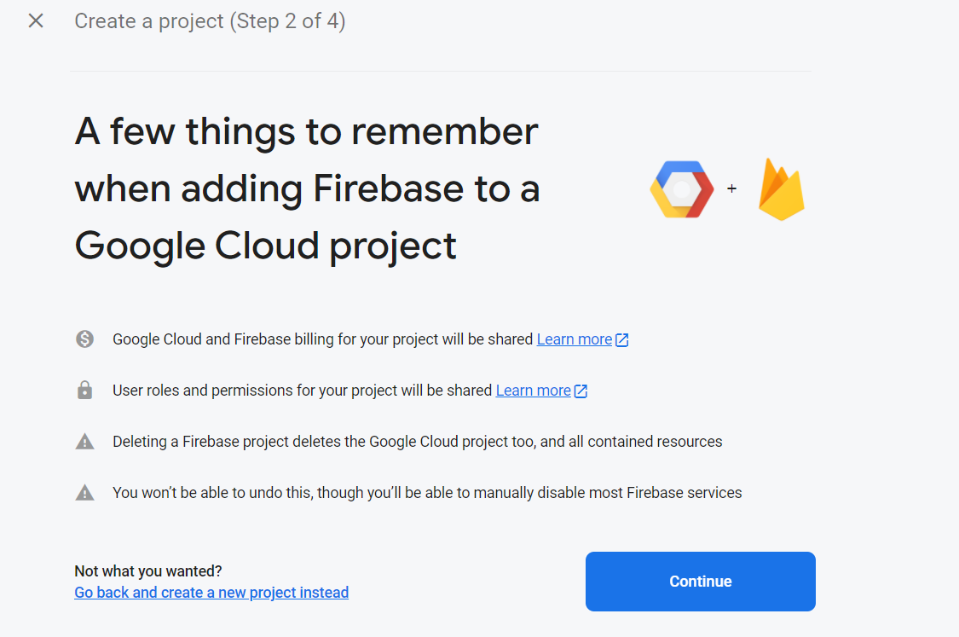

1. Confirming Bill:

1. Created console project

1. Google analytics and project ready :

8. Setup IOS app:

9. Registered app:

10. Added firebase to iOS app:

11. Setup in IDE

12.Added firebase SDK:

13. Installed cocoapods in local and added ‘Firebase/Analytics’ to POD file:

14 Target dependencies and installed:

15. Added initialization code

16. Next steps continued with Firebase Console:

17. Training with Flower Data with 6 categories:

18. AutoMl Training:

19.Enabled AutoML Vision:

20. Added flower dataset by uploading it to AutoML Vision:

21. Imported the data and created bucket:

22. Bucket Setup

23. Flower Dataset after uploaded :

24. Training the Model Using AutoML Vision:

25. Model Optimization:

26. Set the budget for node training hour: 1

27. Trained Model:

28. Model Evaluation:

29. Confusion Matrix:

30. Exporting the TFLight package:

31. Successfully Running the MLVisionFLExample.app using iOS App Simulator

32. From app:

